MINISTRY OF EDUCATION & TRAINING

**HO CHI MINH CITY UNIVERSITY OF ECONOMICS AND FINANCE**

**END-TERM REPORT**

**Course: Mobile-app Development**

**Class: A02E**

**Electric Bill Management**

**Lecturer:** LÊ VIẾT LINH

**Group members:**

LÊ NGỌC HẢO MSSV: 215052081

TRIỆU GIA KHIÊM MSSV: 225054154

NGUYỄN HOÀNG THỊNH MSSV: 205170889

**Ho Chi Minh city - October , 2024**

**Appendix**

**I.** **Database design** 3

**1.** **TABLE Customer** 3

**2.** **TABLE Customer and Electric_user_type.** 4

**II.** **Function** 5

**1.** **Login** 5

**2.** **Main menu** 6

**3.** **Add customer** 7

**4.** **View customer list** 9

**5.** **View customer detail** 10

**6.** **Update customer data** 11

**7.** **Increase electric price** 13

**8.** **Search customer** 14

**9.** **Setting** 16

**III.** **Testing** 17

**1.** **Test case 1**: Add customer with customer list and customer details 17

**2.** **Test case 2**: Increase Electric Price 20

**3.** **Test case 3**: Update customer 22

**4.** **Test case 4**: Customer’s data is change after updating 23

**5.** **Test case 5**: Search customer by name 24

**6.** **Search customer by address** 25

1. **Database design**

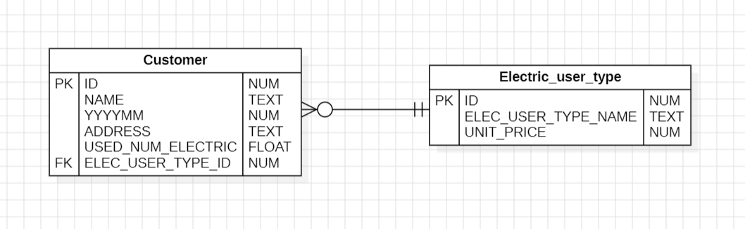

In our project, we kept the database design which was given by our lecturer, the database’s name is Electric Bill Management. It has 2 tables: Customer and Electric_user_type.

1. **TABLE Customer**

CREATE TABLE "CUSTOMER" (

"ID" INTEGER NOT NULL,

"NAME" VARCHAR(50),

"YYYYMM" INTEGER,

"ADDRESS" INTEGER,

"USED_NUM_ELECTRIC" REAL,

"ELEC_USER_TYPE_ID" INTEGER,

PRIMARY KEY("ID" AUTO INCREMENT),

FOREIGN KEY("ELEC_USER_TYPE_ID")

REFERENCES "ELECTRIC_USER_TYPE"("ID"));

1. **TABLE Customer and Electric_user_type.**

CREATE TABLE "ELECTRIC_USER_TYPE" (

"ID" INTEGER NOT NULL,

"ELEC_USER_TYPE_NAME" TEXT,

"UNIT_PRICE" INTEGER,

PRIMARY KEY("ID" AUTOINCREMENT));

1. **Function**
2. **Login**

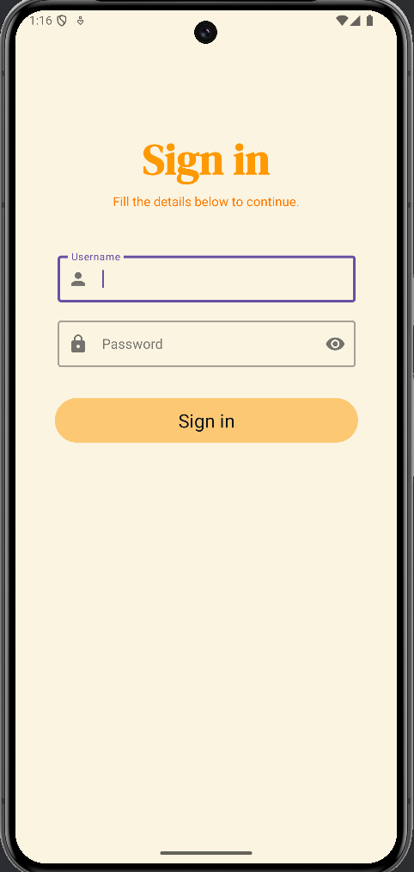

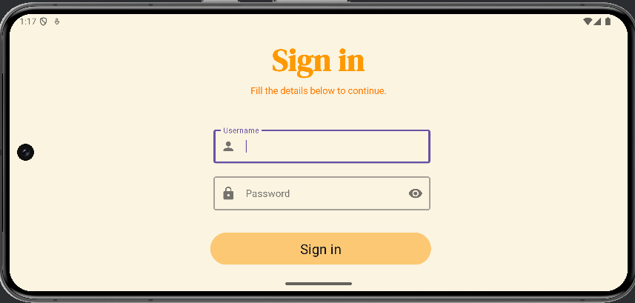

This is the first function of the application, before accessing the application, user have to sign in, there are just one script for this:

* Username: user
* Password: user

If the username or password is incorrect, the fields will be cleared, and the user will need to fill them in again.

1. **Main menu**

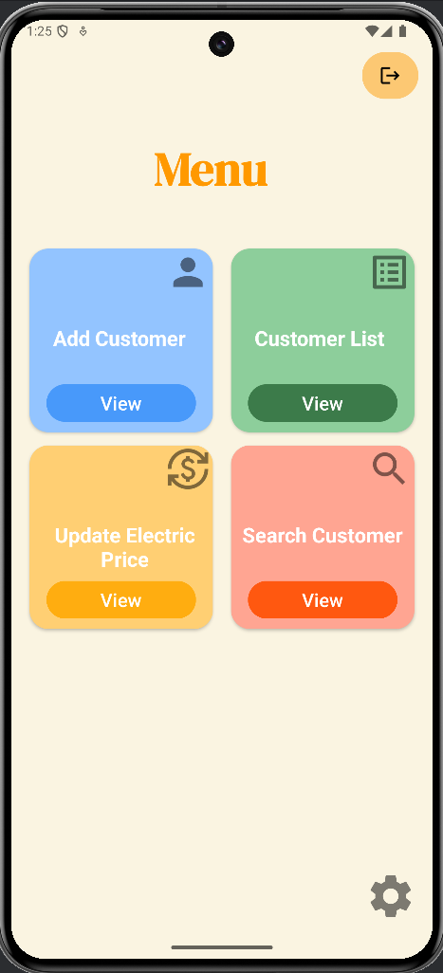  
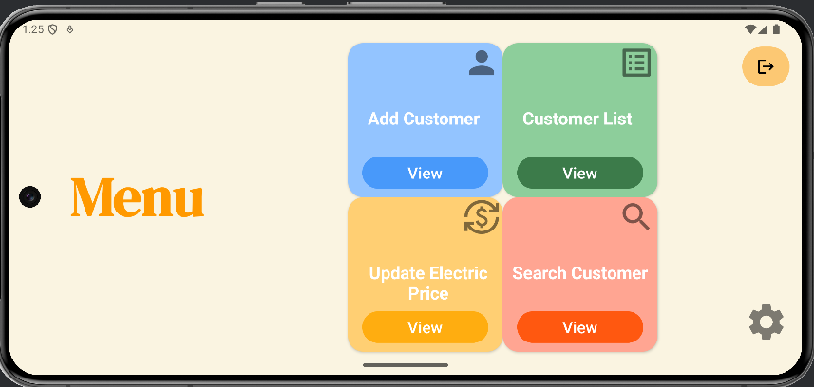

This is the main menu GUI, it allows the user to access all functions, including managing customers, hiding/showing information, or playing music.

1. **Add customer**

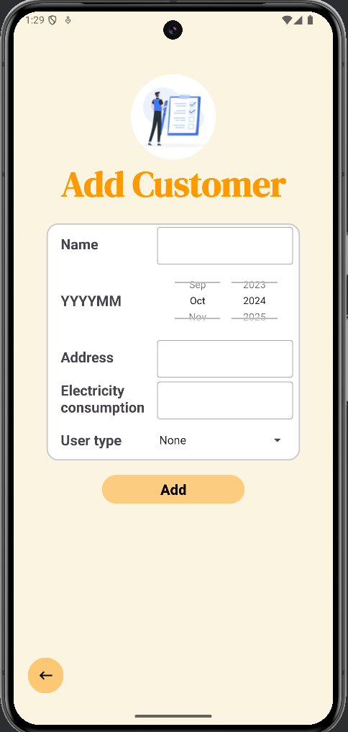

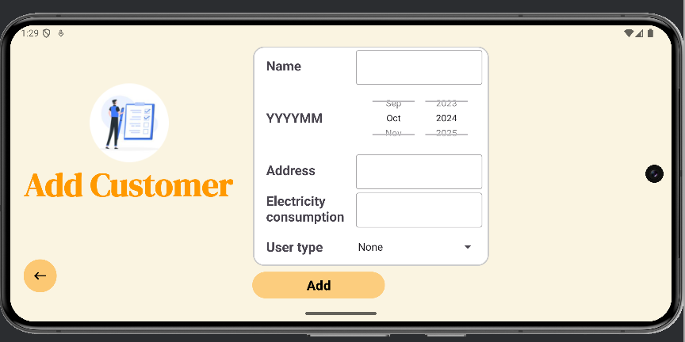

In this function, user can add new customer into database.

If all data is not filled in, a Toast will appear

1. **View customer list**

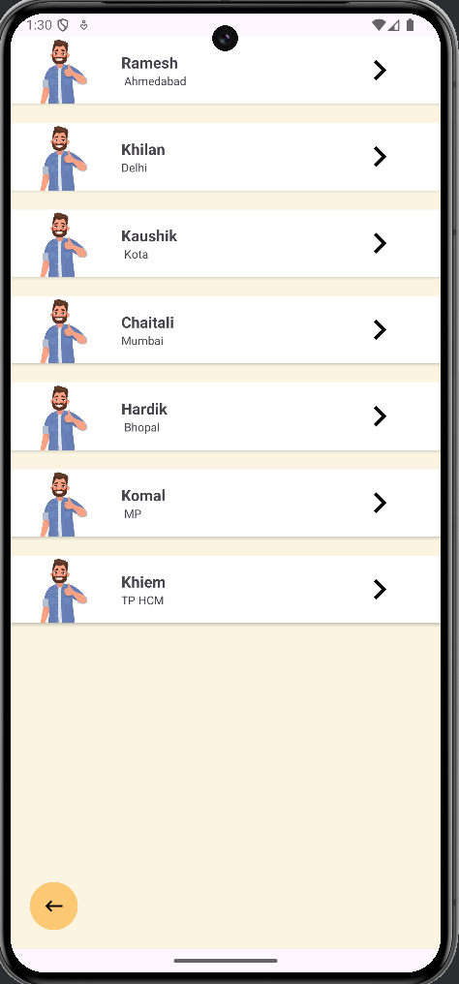

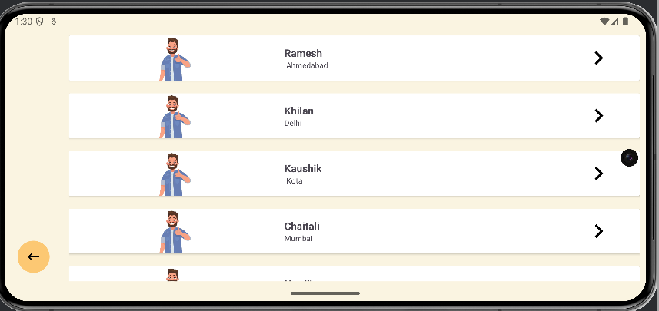

In this function, the user can see a list of all customers. User can scroll down until reach the end of the list. They can also view details of each customer

1. **View customer detail**

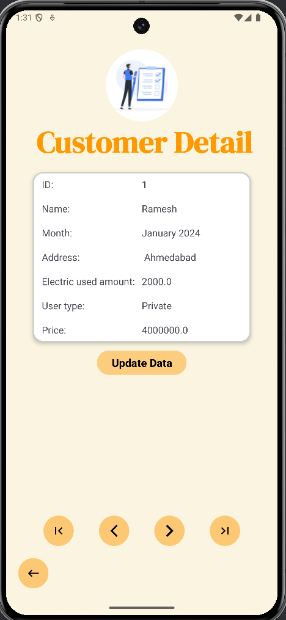

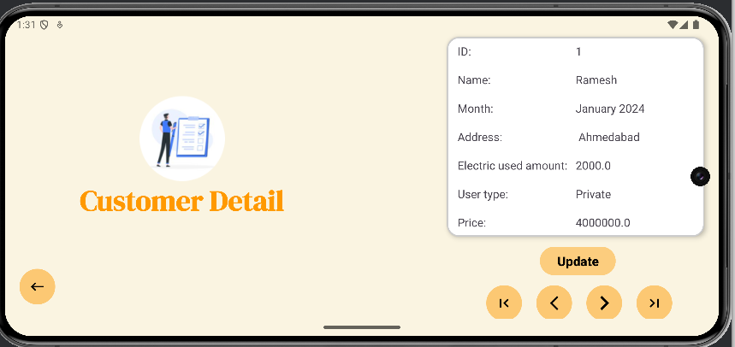

In this function, user can view all details or just a part of details (in setting) by clicking on a customer in the customer list.

The user can view the next, previous, first, or last customer by clicking on the buttons below the 'Update' button.

User can also update customer’s data by clicking on “Update” button.

1. **Update customer data**

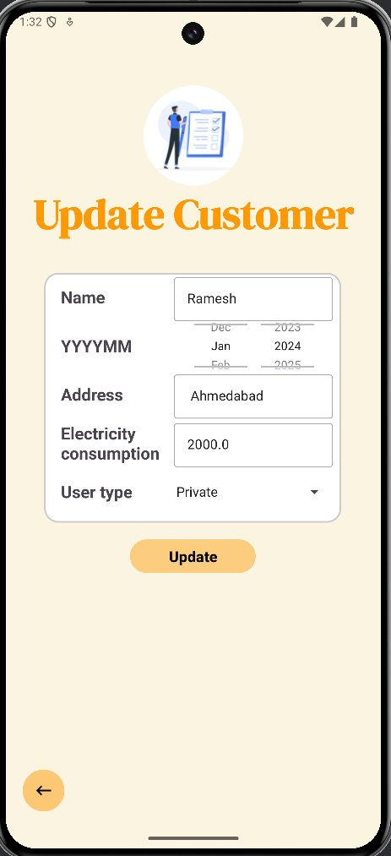

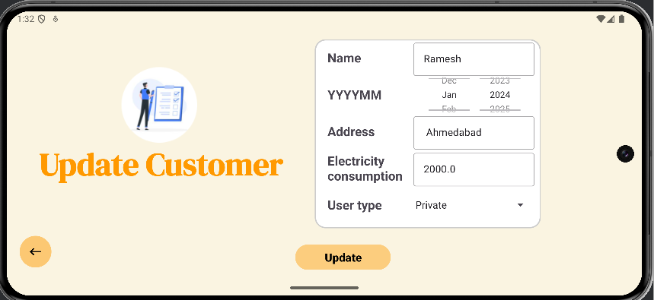

User can update customer’s data in this function. By clicking on “Update” button in “Customer Detail” GUI, system will copy all data of the chosen customer, send them and display in this GUI. Then user can change data if necessary.

When the user clicks on the 'Update' button, the data will be changed, and a Toast will appear.

1. **Increase electric price**

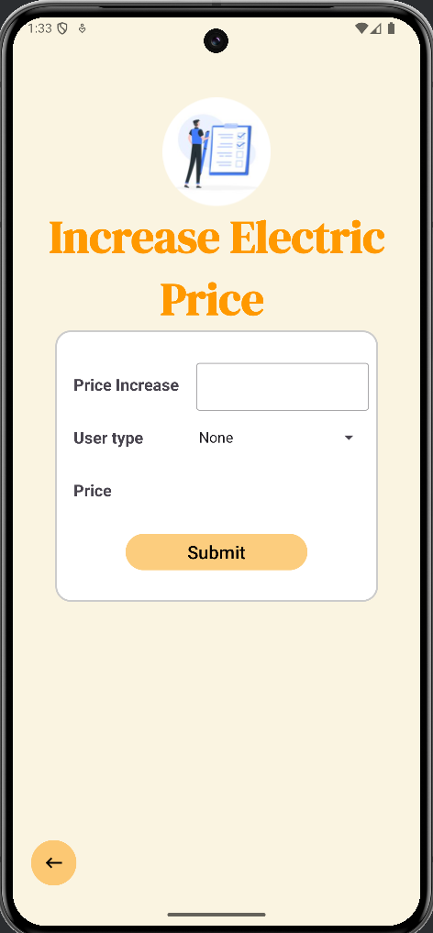

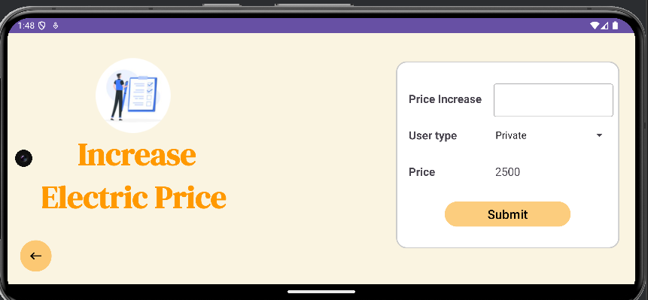

In this function, user can insert the amount of increasing of electric unit price. ( Example : 500 ) and press button “Electric unit price increase” then unit price is updated in database and * create 1 notification with content is: “Already increase electric unit price for user type <name of user type> with amount <amount> at <time in DD/MM/YYYY HH:MM:SS format>”)

User can also know the before and after increasing price by typing listener.

1. **Search customer**

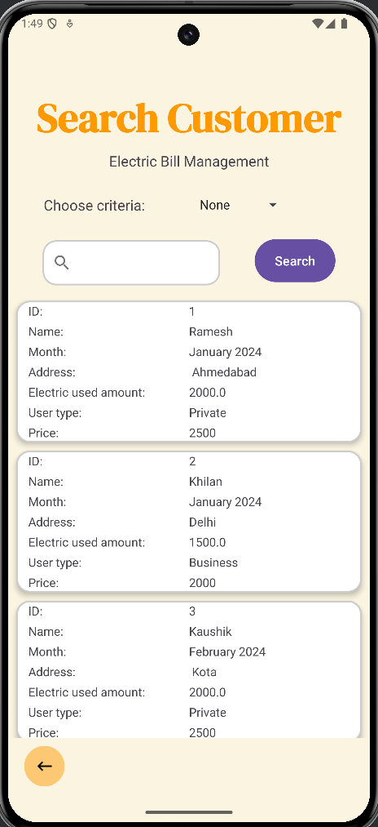

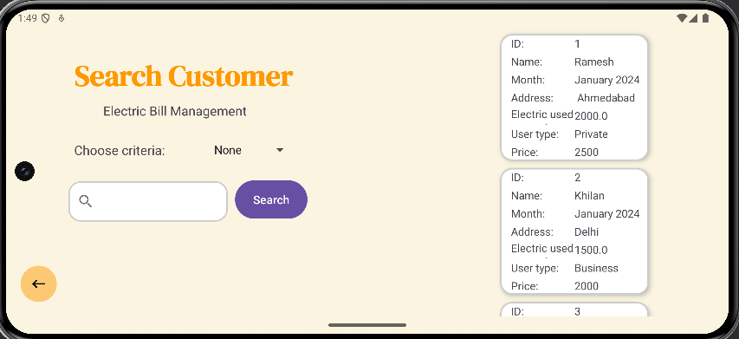

In this function, user can find customer by inserting data into the search bar and press “Search” button, but if user forget to choose criteria to find, the search engine won’t run and a Toast will appear to remind customer.

If all data is inserted, the GUI will display the customers whose names or addresses contain the searched string

1. **Setting**

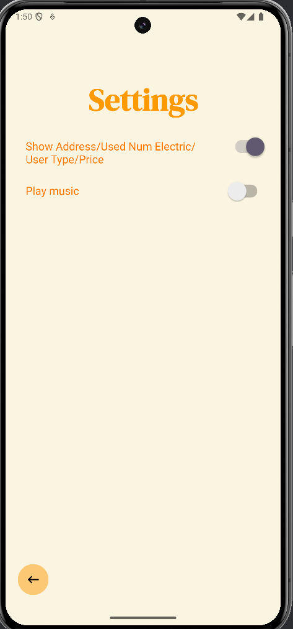

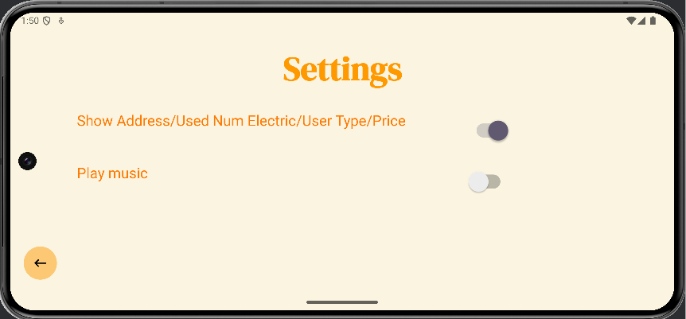

In this GUI, user can show or hide data in “Customer Detail” GUI and play music as long as user is still in the application.

1. **Testing**
2. **Test case 1**: Add customer with customer list and customer details

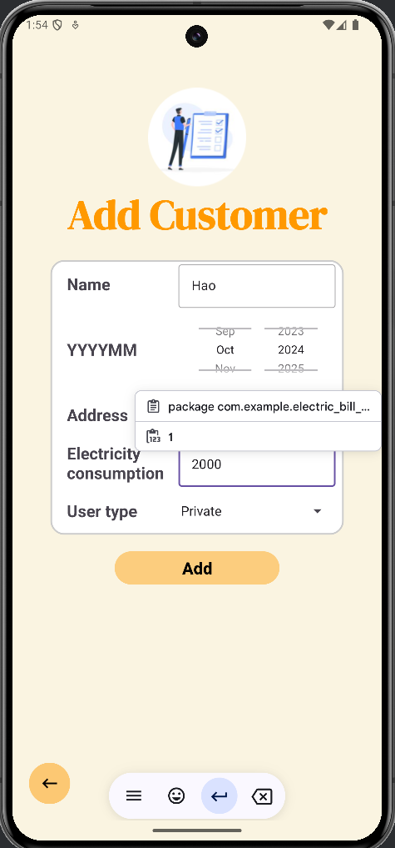

* After adding, new customer generated in customer list and details

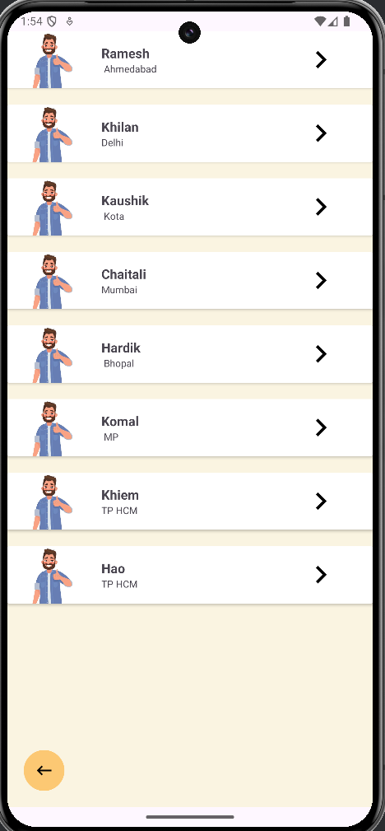

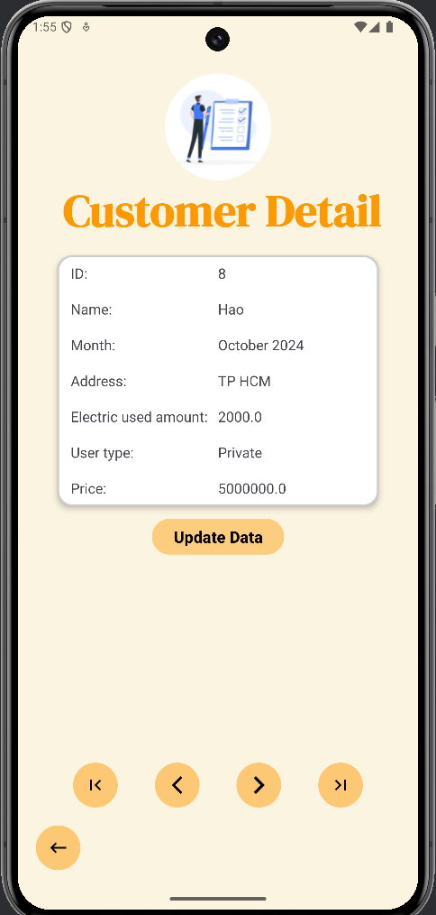

1. **Test case 2**: Increase Electric Price

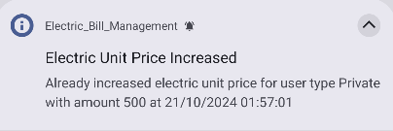

* A notice is generated after increasing price

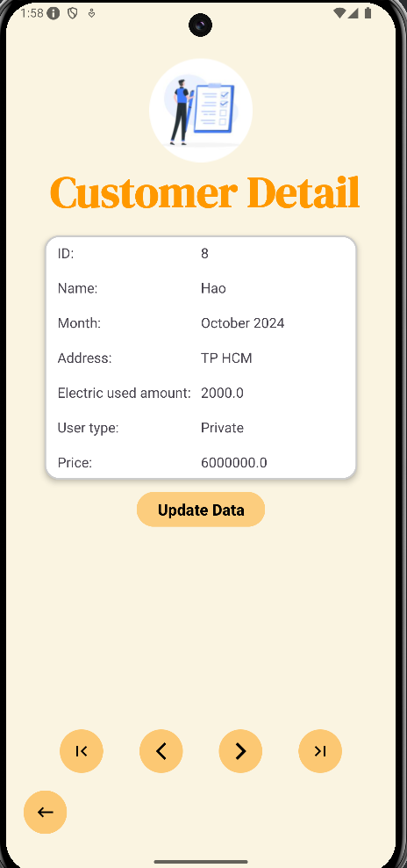

* The price change is reflected in the customer details.

1. **Test case 3**: Update customer

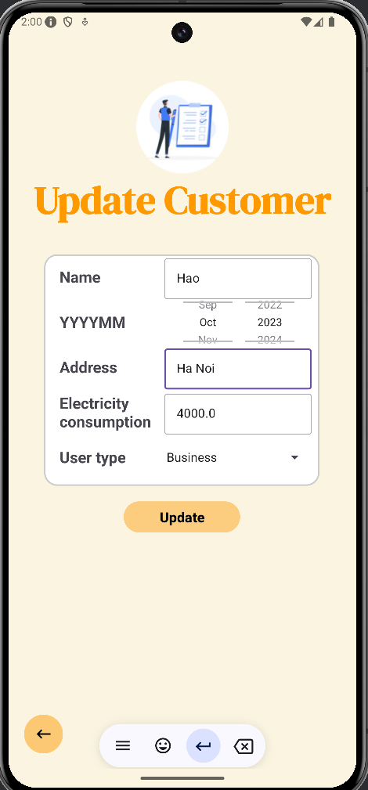

1. **Test case 4**: Customer’s data is changed after updating

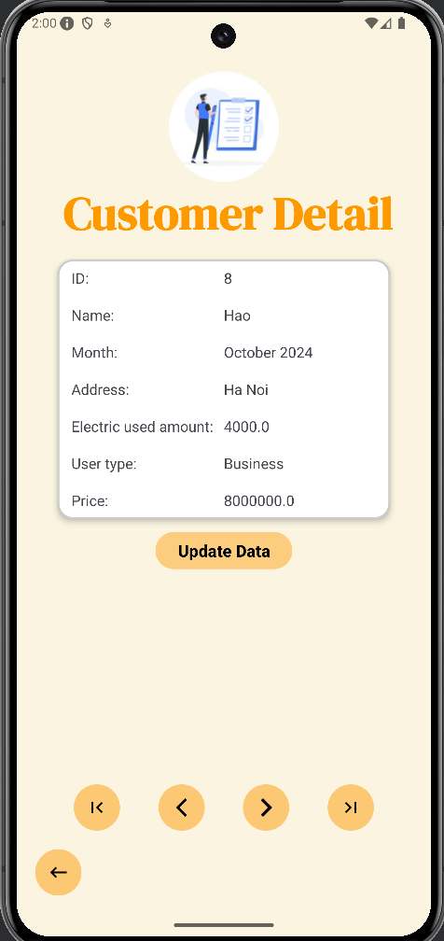

1. **Test case 5**: Search customer by name

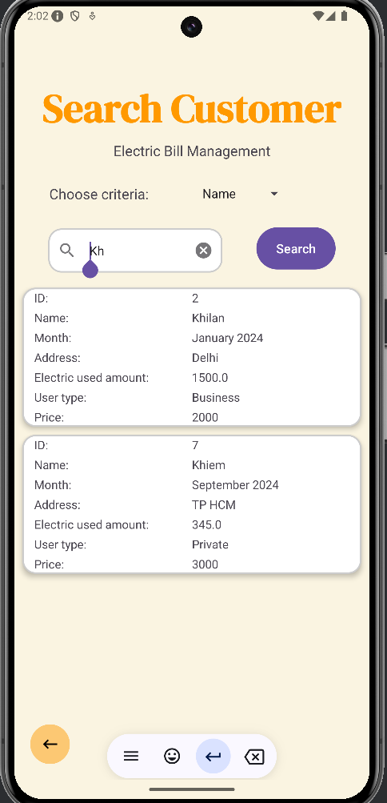

1. **Search customer by address**

